
(An Autonomous Institution, Affiliated to Anna University, Chennai)
MINI PROJECT

IPL 2025 DATA ANALYSIS AND VISUALIZATION
Framework for Data Visual Analytics

JAGADISH S A
(241501071)

ABSTRACT

This mini project, carried out for the subject Framework of Data Visualization and Analytics (FDVA), analyses the Indian Premier League (IPL) 2025 season using Python, Microsoft Power BI and Tableau. Four files were used: matches.csv (74 matches, 22 columns), deliveries.csv (17,183 ball-by-ball records, 19 columns), orange_cap.csv (top 15 run-scorers) and purple_cap.csv (top 15 wicket-takers). The raw match file had missing values in 14 columns (103 empty cells in total), numeric margins stored as text (including the entry “super over”), dates in two different formats across the files, and three matches with no result. Python with Pandas was used to correct these problems and to create new columns such as Win_Type, Total_Match_Runs, Batting_First and Toss_Winner_Won in the match file, and Total_Runs, Is_Wicket and Phase in the deliveries file. The cleaned files have 74 rows × 32 columns and 17,183 rows × 25 columns. Matplotlib and Seaborn were then used to create eight charts, including team-wise wins, venue-wise scoring, toss decisions, top run-scorers and wicket-takers, runs per over and a correlation heatmap. Interactive dashboards were also designed in Power BI and Tableau using slicers for team, venue and stage, KPI cards and charts by team and venue. The analysis showed that Punjab Kings (PBKS) won the most matches (11), Royal Challengers Bengaluru (RCB) won 10 and lifted the title by beating PBKS in the final, teams that won the toss chose to bowl in 82.4% of matches, and Sai Sudharsan of Gujarat Titans (GT) topped the run charts with 759 runs. The project shows how preprocessing, charts and dashboards turn raw cricket records into clear information that can support team and strategy decisions.

1. Data Preprocessing
The main dataset (matches.csv) has 74 rows and 22 columns. The ball-by-ball file (deliveries.csv) has 17,183 rows and 19 columns, and the two cap files have 15 rows each. They were cleaned in Python using Pandas, as shown below.

Loading and inspecting the data
import pandas as pd, numpy as np
m = pd.read_csv("matches.csv") # (74, 22)
d = pd.read_csv("deliveries.csv") # (17183, 19)
oc = pd.read_csv("orange_cap.csv") # (15, 16)
pc = pd.read_csv("purple_cap.csv") # (15, 14)
m.info()
The columns wb_runs and wb_wickets (winning margin by runs or by wickets) and the date columns were stored as text and had to be converted.

Missing values and duplicates
print(m.isnull().sum())
print("Duplicate rows:", m.duplicated().sum(), d.duplicated().sum())
The match file had 103 missing cells across 14 columns. Most were expected: wb_runs (40) is empty when the chasing team wins and wb_wickets (36) is empty when the team batting first wins. Three matches ended with no result (no winner, no player of the match), which explains the 3 missing values in match_winner, player_of_the_match, top_scorer, highscore and best_bowling. Real gaps were toss_winner (1), first_ings_score (1), second_ings_score (2) and balls_left (2). The deliveries file had missing wicket_type, player_dismissed and fielder only on balls with no wicket, which is normal. No duplicate rows were found (0 in both files).

Fixing data types and filling missing values
m['wb_runs'] = pd.to_numeric(m['wb_runs'], errors='coerce')
m['wb_wickets'] = pd.to_numeric(m['wb_wickets'], errors='coerce')
for c in ['first_ings_score','first_ings_wkts','second_ings_score',
'second_ings_wkts','balls_left','highscore']:
m[c] = m[c].fillna(m[c].median())
m['wb_runs'] = m['wb_runs'].fillna(0)
m['wb_wickets'] = m['wb_wickets'].fillna(0)
m['match_winner'] = m['match_winner'].fillna('NO RESULT')
m['toss_winner'] = m['toss_winner'].fillna('NOT RECORDED')
m['player_of_the_match'] = m['player_of_the_match'].fillna('Not Awarded')
The text “super over” in wb_runs and wb_wickets (match 32, Delhi Capitals vs Rajasthan Royals, scores level at 188) was turned into a missing value by errors='coerce' and recorded separately in a new Win_Type column. Numeric columns were filled with the median, margins that do not apply were set to 0, and labels such as NO RESULT and Not Awarded were used for text columns. After this, every column had 0 missing values.

Standardising text values
for c in ['team1','team2','toss_winner','match_winner']:
m[c] = m[c].astype('string').str.strip().str.upper()
m['toss_decision'] = m['toss_decision'].str.strip().str.upper()
m['stage'] = m['stage'].str.strip().str.title()
Spaces were removed and the team codes (CSK, MI, RCB, KKR, SRH, RR, DC, PBKS, GT, LSG), toss decision (BAT or BOWL) and stage (League, Playoffs, Final) were written in one standard form so that groupby and counting work correctly.

Converting the match date
m['date'] = pd.to_datetime(m['date'].str.strip(), format='mixed', errors='coerce')
d['date'] = pd.to_datetime(d['date'].str.strip(), format='mixed', errors='coerce')
m['Match_Month_Name'] = m['date'].dt.month_name()
The match file wrote dates as “March 22,2025” and the deliveries file as “Mar 22, 2025”. Using format='mixed' parsed both, and no date was missing (0) afterwards.

New columns and export
# matches
m['Win_Type'] = np.where(m.wb_wickets.isna(), 'Super Over', ...) # Runs / Wickets / Super Over / No Result
m['Total_Match_Runs'] = m.first_ings_score + m.second_ings_score
m['Toss_Winner_Won'] = np.where(m.toss_winner == m.match_winner, 'YES', 'NO')
bf = m['best_bowling_figure'].str.split('--', expand=True).astype(int)
m['Best_Wickets'], m['Best_Runs_Conceded'] = bf[0], bf[1]
# deliveries
d['Total_Runs'] = d.runs_of_bat + d.extras
d['Is_Wicket'] = d.player_dismissed.notna().astype(int)
d['Over_No'] = np.floor(d.over).astype(int) + 1
d['Phase'] = pd.cut(d.Over_No, [0,6,15,20],
labels=['Powerplay (1-6)','Middle (7-15)','Death (16-20)'])
m.to_csv("Cleaned_IPL_Matches.csv", index=False) # (74, 32)
d.to_csv("Cleaned_IPL_Deliveries.csv", index=False) # (17183, 25)
Ten columns were added to the match file (Win_Type, Win_Margin, Best_Wickets, Best_Runs_Conceded, Match_Year, Match_Month, Match_Month_Name, Total_Match_Runs, Toss_Winner_Won, Batting_First) and six to the deliveries file (Total_Runs, Is_Wicket, Over_No, Phase, Is_Four, Is_Six). The cleaned files were saved and used for the visualizations and dashboards.

2. Data Visualization Using Python
Eight charts were created from the cleaned data using Pandas, Matplotlib and Seaborn (sns.set_theme(style="whitegrid")). Each chart is explained briefly below.
Figure 2.1: Matches won by team (sns.countplot)
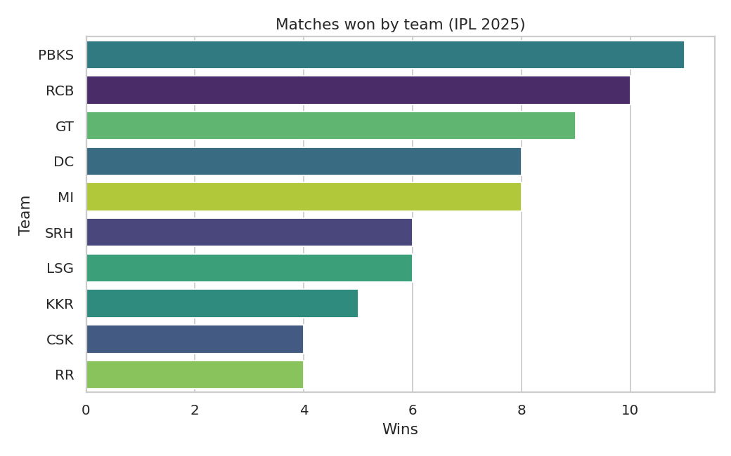
Result: PBKS won the most matches (11), followed by RCB (10) and GT (9). CSK and RR won only 4 each. Three matches had no result and are not counted.
Figure 2.2: Matches hosted by venue (bar chart)
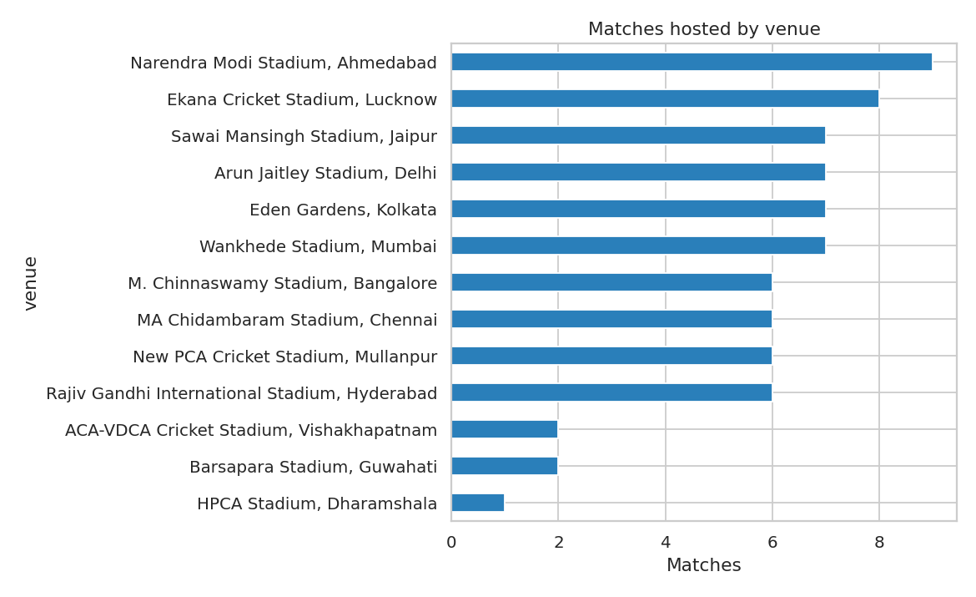
Result: Narendra Modi Stadium, Ahmedabad hosted the most matches (9), then Ekana, Lucknow (8). Dharamshala hosted just 1.
Figure 2.3: Average first-innings score by venue
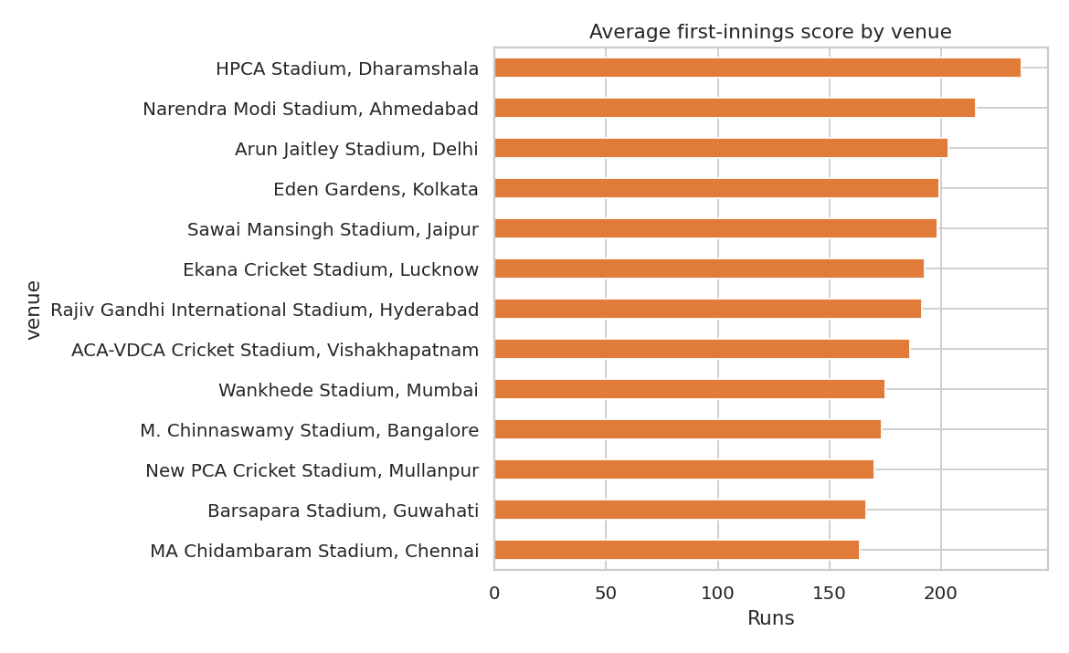
Result: Ahmedabad is the highest-scoring ground with a meaningful sample (about 216 runs in 9 matches); Dharamshala is higher (236) but had only one match. Chennai is the lowest (about 164).
Figure 2.4: Toss decision (pie chart)
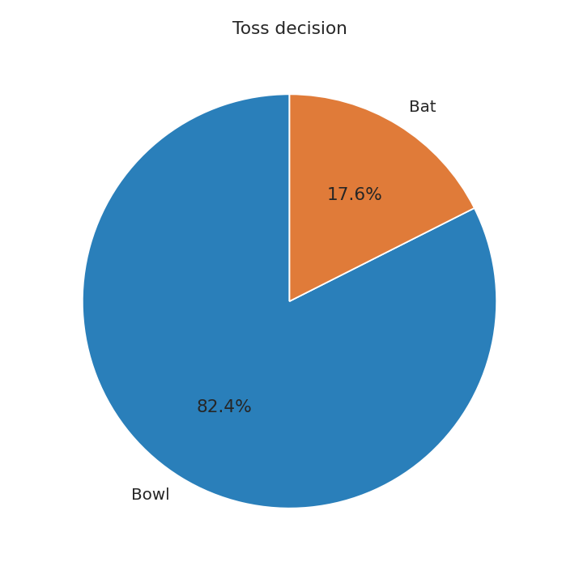
Result: Captains chose to bowl first in 61 matches (82.4%) and to bat in 13 (17.6%).
Figure 2.5: Top 10 run-scorers (Orange Cap) and wicket-takers (Purple Cap)
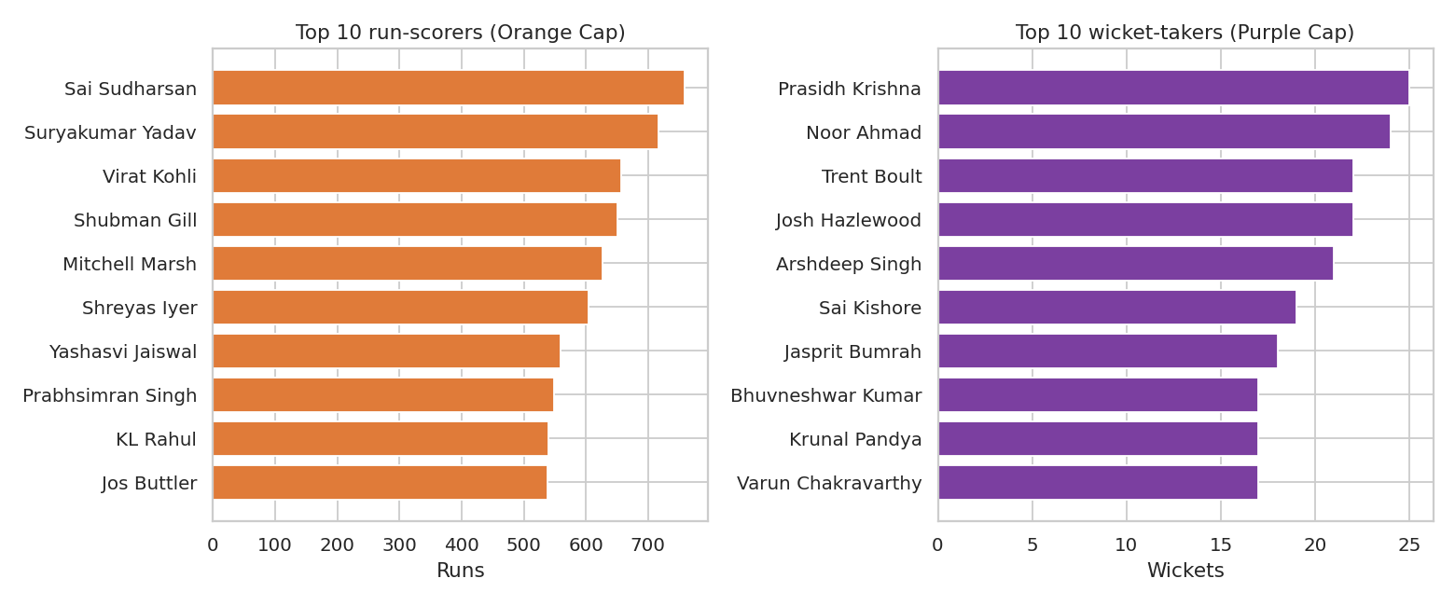
Result: Sai Sudharsan (GT) led with 759 runs, ahead of Suryakumar Yadav (717) and Virat Kohli (657). Prasidh Krishna (GT) took the most wickets (25), followed by Noor Ahmad (24).
Figure 2.6: Average runs per over, by innings (line chart)
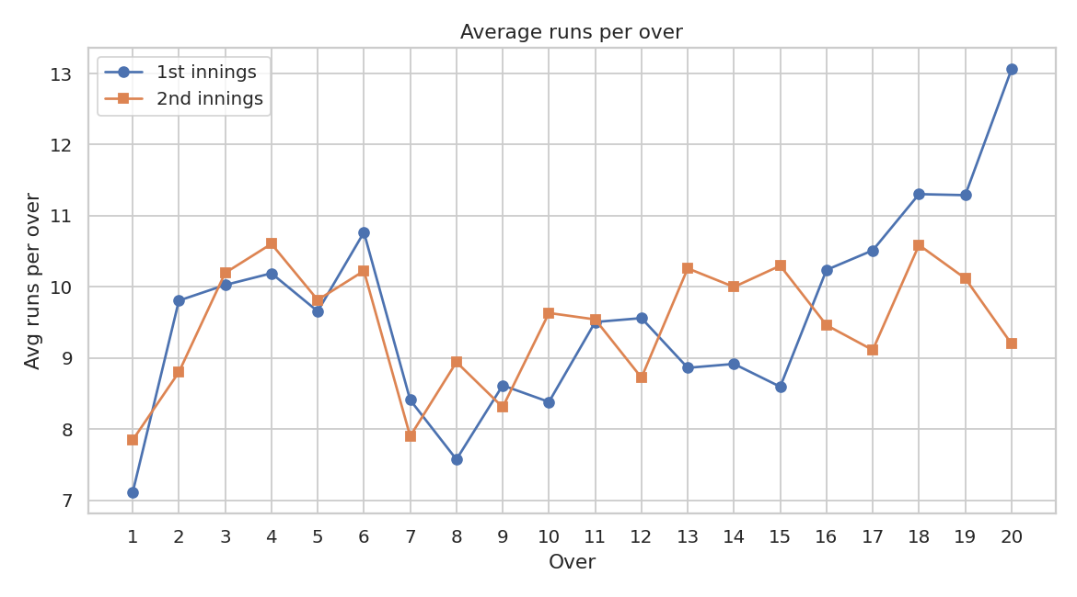
Result: Scoring is lowest in over 1 of the first innings (about 7.1 runs) and highest in over 20 of the first innings (about 13.1). The Powerplay averages 9.20 runs per over, the middle overs 8.69 and the death overs 10.28.
Figure 2.7: First-innings score vs second-innings score (scatter plot)
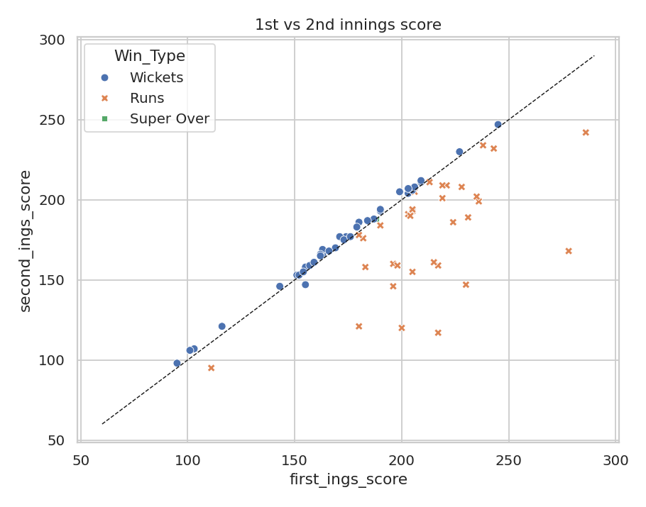
Result: The two scores are moderately related (correlation about 0.59); chases of large totals mostly fall short of the dashed equal-score line.
Figure 2.8: Correlation heatmap
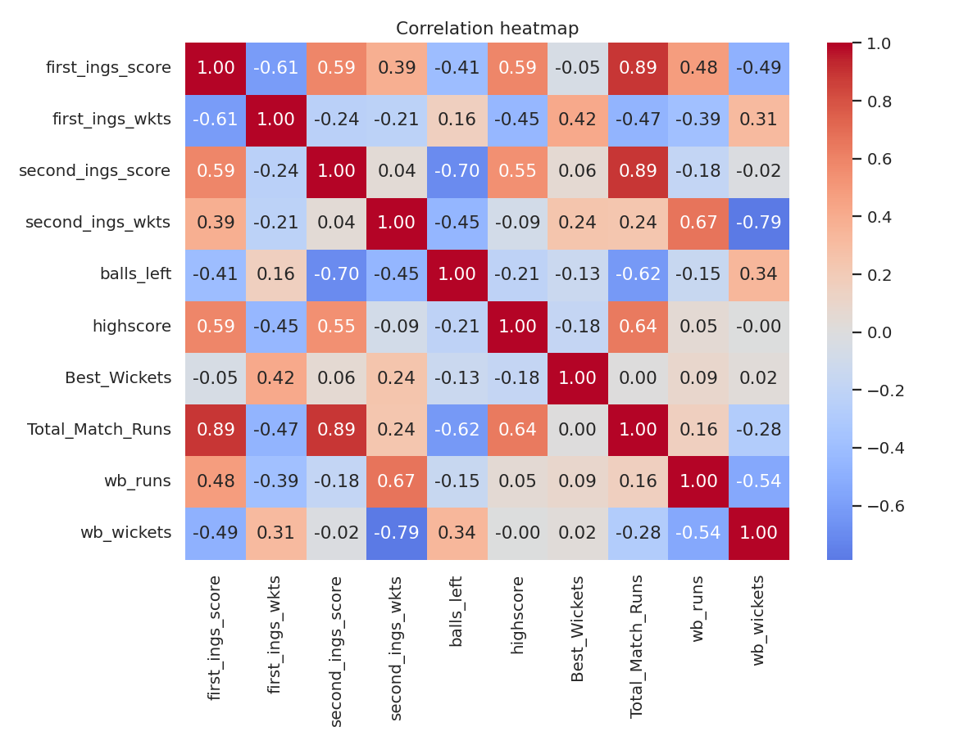
Result: The strongest relations are second_ings_wkts with wb_wickets (-0.79) and second_ings_score with balls_left (-0.70). A chasing team that loses fewer wickets wins by more wickets, and a team that scores more in the chase wins with fewer balls to spare. Most other pairs are weak.
Overall, bowling first was the clear choice at the toss, and teams that won the toss won 42 of the 71 decided matches (59.2%). Chasing and defending were almost even: 36 wins for the chasing side against 35 for the side batting first. The most successful team in the league (PBKS) finished runners-up to RCB in the final, and the top run-scorer (Sai Sudharsan) came from GT, not from the champion team.

3. Power BI Dashboard
Power BI was used to build a one-page interactive dashboard from Cleaned_IPL_Matches.csv, Cleaned_IPL_Deliveries.csv and the two cap files.
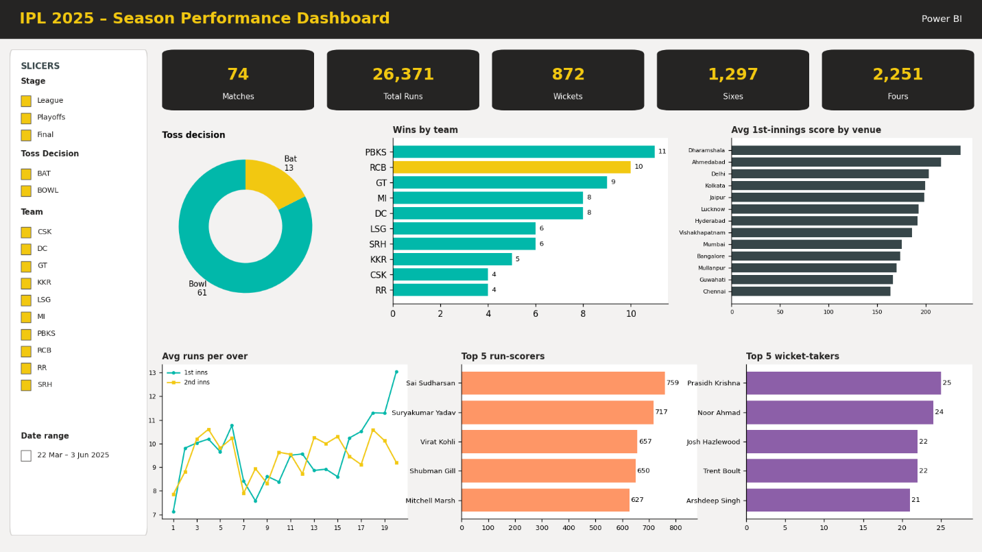

Figure 3.1: IPL 2025 Dashboard in Power BI
Slicers: Team (batting_team), Venue, Stage (League, Playoffs, Final) and Toss Decision filter the whole page.
- KPI cards: Matches 74, Total Runs 26,371, Total Wickets 872, Sixes 1,297 and Fours 2,251 (ball-by-ball file, 73 matches because match 58 was washed out).
- Charts: a donut chart of toss decision (Bowl 82.4%, Bat 17.6%), a bar chart of wins by team, a column chart of average first-innings score by venue, a line chart of runs per over for each innings, and a table of the top run-scorers and wicket-takers.
- Insights: PBKS lead in wins (11), Ahmedabad is the highest-scoring venue, and the death overs (16-20) are the most productive phase at 10.28 runs per over.
- Note: sort the venue chart by value, and the over chart by over number, so the order is easy to read.

4. Tableau Dashboard
Tableau was used to build the “IPL 2025 Performance & Match Insights Dashboard” from the same cleaned data.

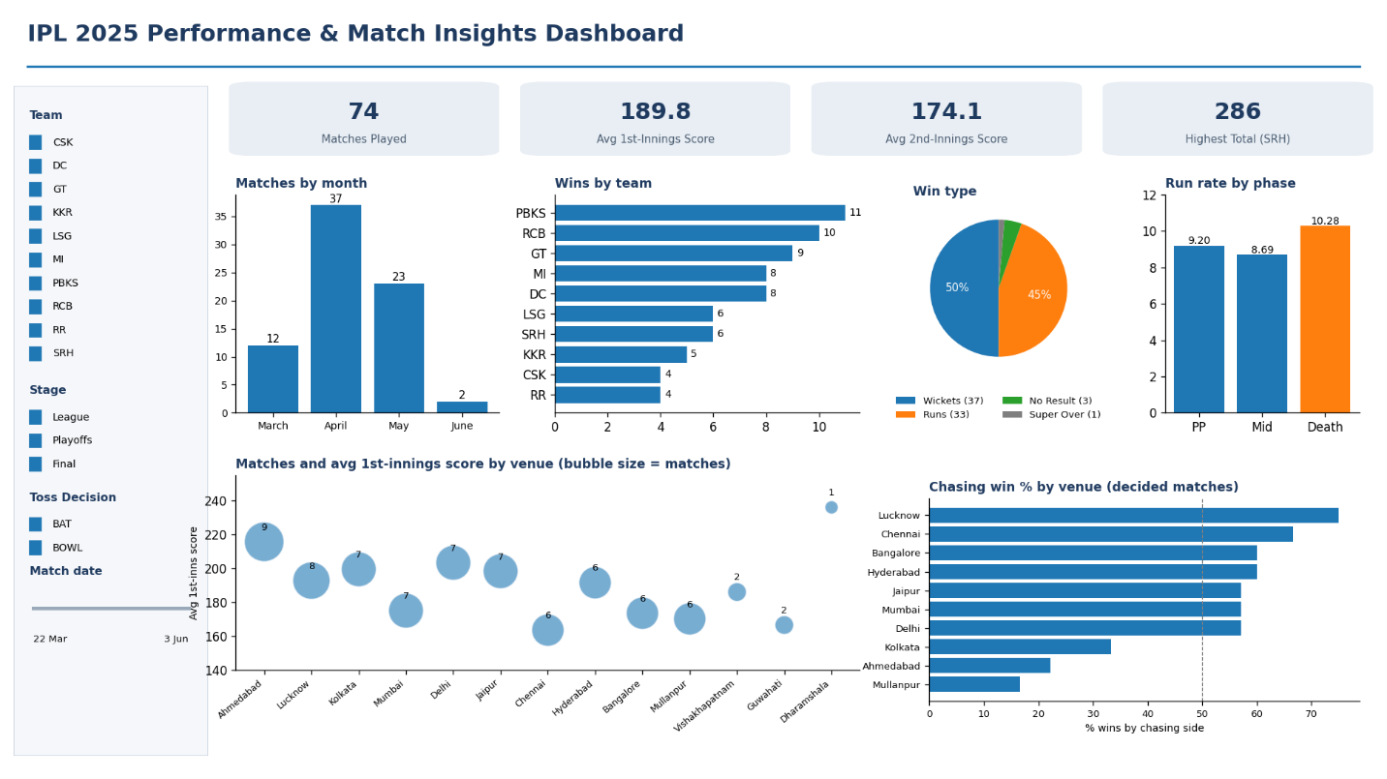

Figure 4.1: IPL 2025 Dashboard in Tableau
- Filters: Team, Venue, Stage and Toss Decision check lists, and a match-date range slider (22 March to 3 June 2025).
- KPIs: Matches Played 74, Average First-Innings Score 189.8, Average Second-Innings Score 174.1 and Highest Total 286 (SRH vs RR, Hyderabad).
- Charts: monthly match count (March 12, April 37, May 23, June 2), wins by team (bar), win type split (Wickets 37, Runs 33, Super Over 1, No Result 3), phase-wise run rate (Powerplay 9.20, Middle 8.69, Death 10.28), and a venue map of India.
- Insights: Batting second won slightly more often than batting first (36 vs 35 of 71 decided matches), but venues differ sharply: chasing teams won only 2 of 9 matches at Ahmedabad and 1 of 6 at Mullanpur, while Lucknow favoured chasing (6 of 8).

5. Conclusion
The IPL 2025 data was cleaned in Python, explored with eight charts, and presented in interactive Power BI and Tableau dashboards. Preprocessing fixed missing values, text-formatted numbers and mixed date formats, and the new columns made match-level and phase-level analysis possible. The results show a bowl-first toss trend, high-scoring venues such as Ahmedabad, a clear death-over scoring surge, and a competitive season in which RCB won the title after a league phase led by PBKS.

